Приложение 1

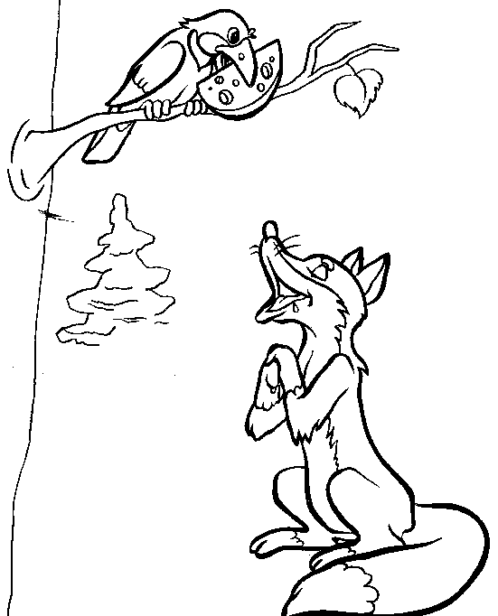

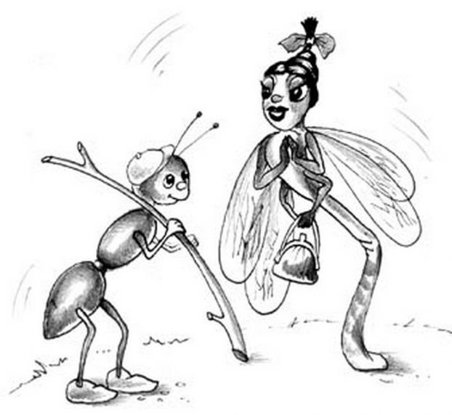Приложение 2

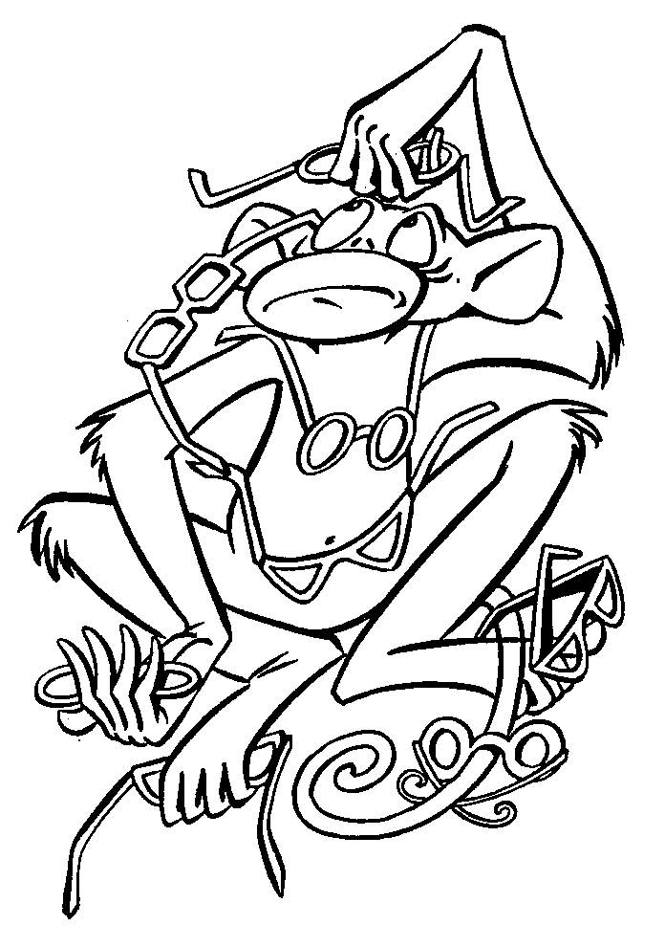

Приложение 3

|  |  |  |  |  |  |  |  |  |
| --- | --- | --- | --- | --- | --- | --- | --- | --- |
|  | |  | 1 | 9 |  |  |  | |
| 2 |  |  |  |  |  |  |
| 3 |  |  |  |  |  |  | | |
|  | | 4 |  |  |  |  |  |  |
|  | | | 5 |  |  |  | |
| 6 |  |  |  |
|  | 7 |  |  |  |
| 8 |  |  |  |

Приложение 4